- We expect the Bank of England's Monetary Policy Committee to hold Bank Rate at 3.75% at next week's meeting. The majority of MPC members anticipate further rate cuts will be required, but they're concerned about the potential strength of 2026 pay awards and their impact on inflation.
- The current bout of mild stagflation is likely to keep the committee divided on the timing of these future cuts, encouraging a gradual approach to loosening policy further.
- We see the end-April meeting as the most likely timing for the next cut. By then, the MPC should have a clearer view of the pay awards and whether there is further evidence of slack emerging in the economy.
At the December meeting of the Bank of England's Monetary Policy Committee, the vote split between the doves and hawks remained very narrow, emphasising how divided the committee has become.
The minutes and individual member summary statements sent two key messages about the outlook for Bank Rate. First, the balance of risks to inflation had tilted in a dovish direction. And second, that judgements around further rate cuts would become closer calls, suggesting that there was little appetite among the majority of committee members to loosen policy again in the near term, after December's cut.
Data published since the December meeting may, at the margin, help to ease some of the MPC's concerns about the stickiness of inflation, particularly those emanating from the labour market. Private sector regular pay growth – the MPC's preferred measure of wages – slowed to 3.6% in the three months to November, slightly undershooting the BoE's most recent staff projections. Although some of this move reflected base effects, which should unwind, momentum has also been soft – the three-month-on-three-month annualised rate is now broadly in line with the pace the MPC considers to be consistent with achieving the 2% inflation target in the medium term (Chart 1).
Chart 1: Pay growth continues to cool, with underlying pressures weak
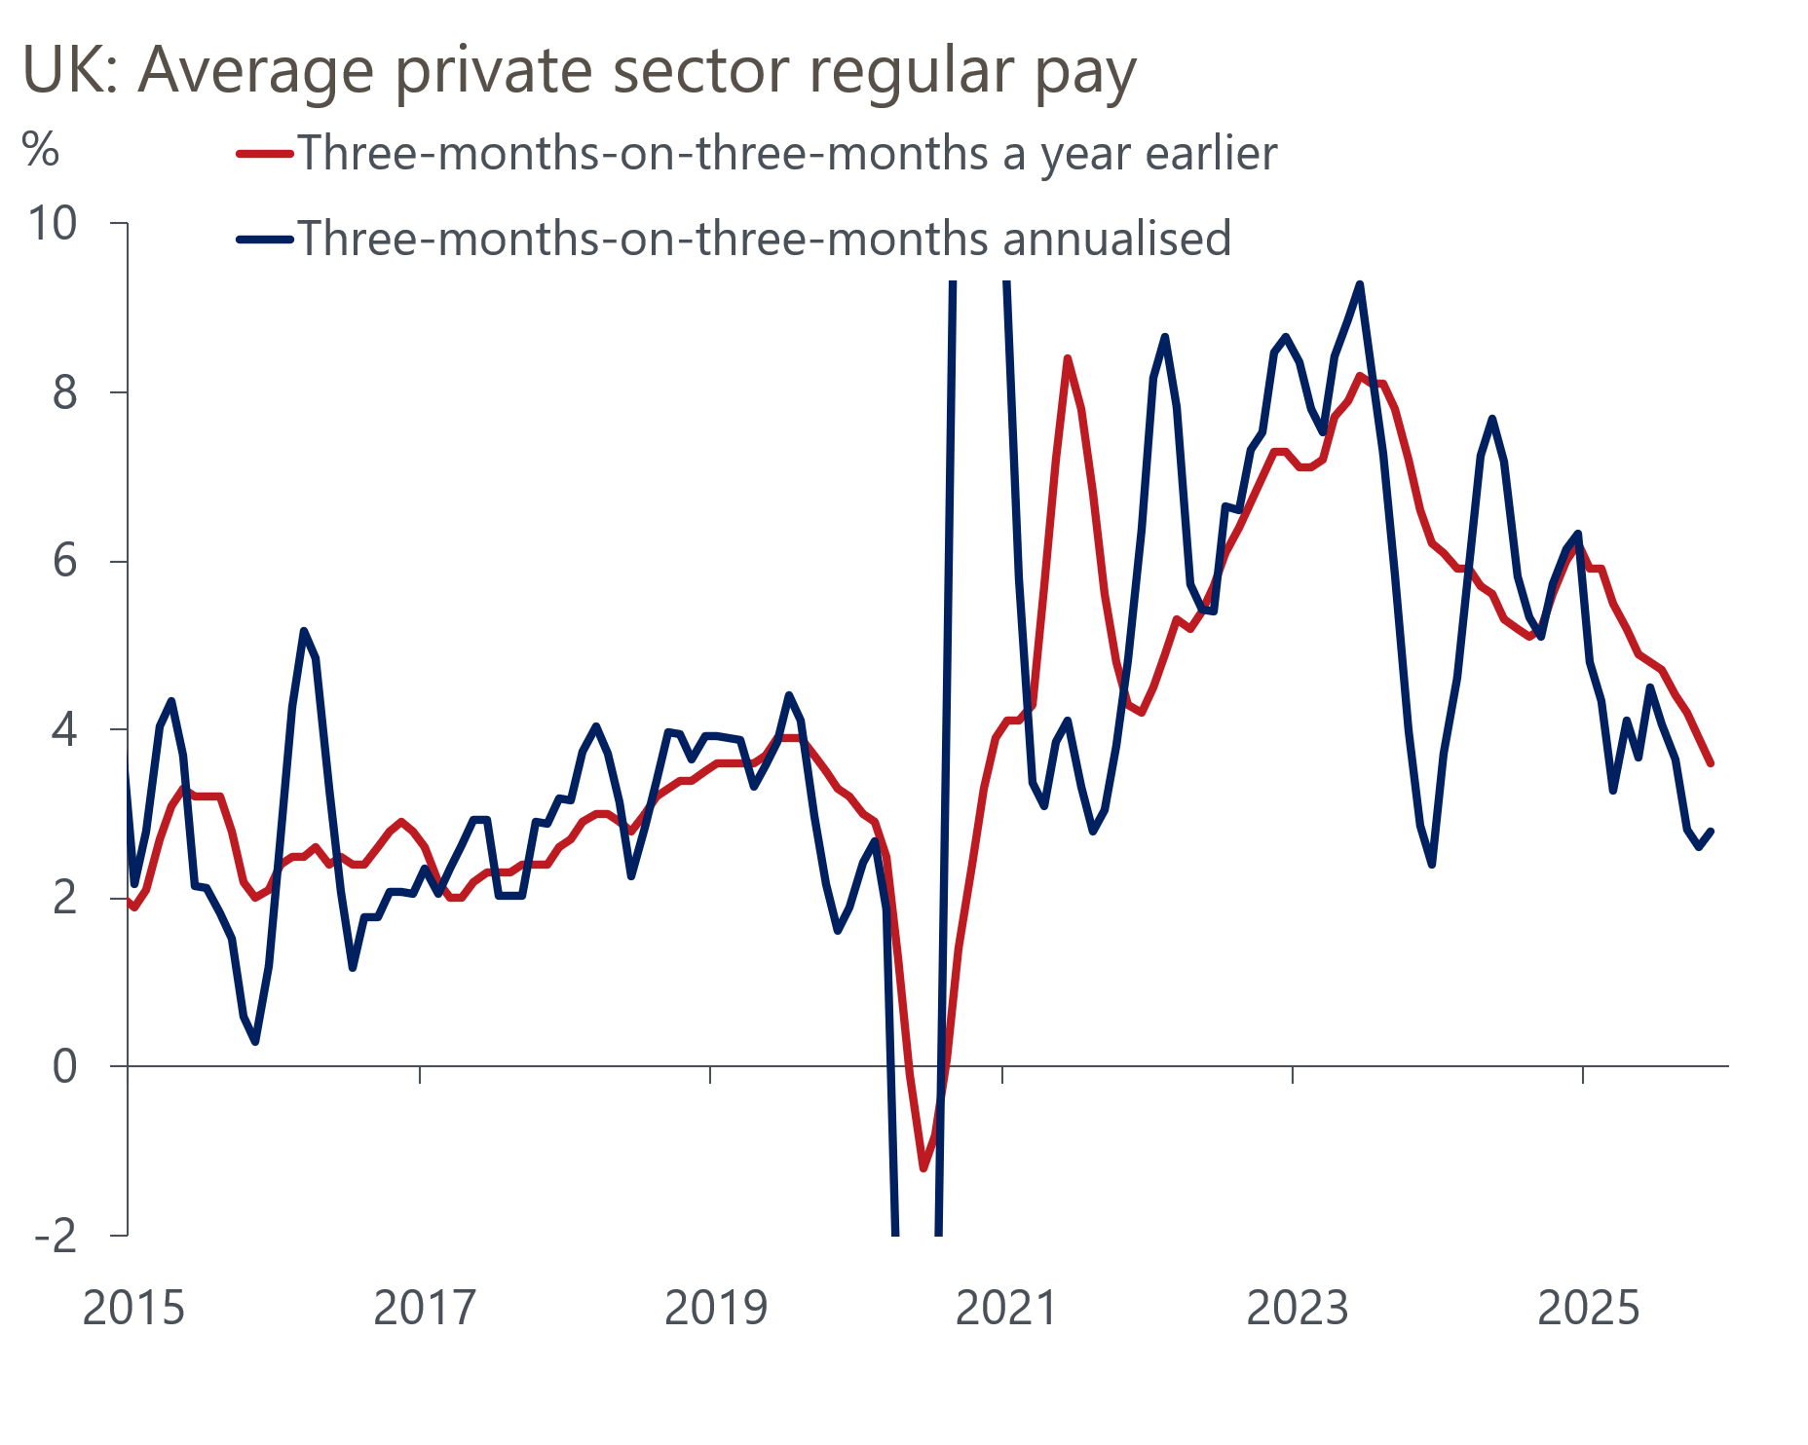
Source: Haver Analytics

However, the MPC remains concerned that pay settlements could start to edge higher again soon. The BoE's Decision Maker Panel for December reported that the downward trend in year-ahead pay growth expectations has plateaued recently, at around 3.7%. Meanwhile, intelligence from the BoE's regional agents suggests that the 2026 new year pay deals are likely to average 3.5%, down only marginally from the 3.7% they reported for early 2025. This would still be above a target-consistent pace.
Evidence that labour market conditions continue to cool suggests the momentum behind pay growth may slow further in the near term. Most notably, HMRC's count of payrolled employees fell by a further 43,000 in December, after a 33,000 drop a month earlier. Although the HMRC measure tends to be revised up over time, these falls were the largest monthly declines seen since late 2020, with the renewed weakening in labour market conditions becoming more broad-based (Chart 2). And weakness in the payrolls data chimes with a range of business surveys and alternative indicators, suggesting the jobs market is in poor shape.
Chart 2: The latest payroll data point to renewed weakness across the labour market
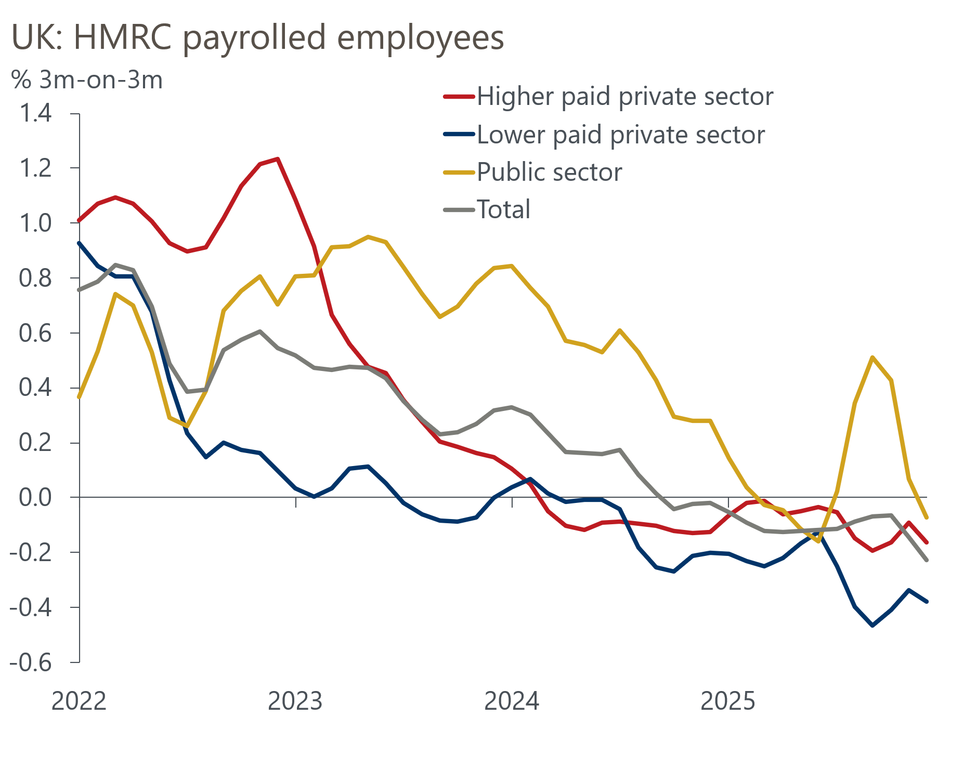
Source: Haver Analytics
Elsewhere, December's CPI inflation reading rose 0.2ppts to 3.4% y/y. However, this was largely due to a combination of the unwinding of earlier weaker outturns across a range of notoriously volatile core sub-categories and the 2025 Budget uprating of tobacco duty, after the 2024 duty increase happened a month earlier. Although both headline and services inflation have come in fractionally weaker than forecast by BoE staff in recent months, the MPC's measure of core services inflation has remained virtually unchanged.
Turning to demand, November's GDP outturn provided a rare upside surprise and suggests output growth in Q4 2025 is likely to come in at 0.1% q/q, marginally higher than the BoE's flat forecast. However, these are small magnitudes, and much of this strength appears to reflect noisy data rather than a strong underlying narrative. As a result, we think the growth outlook is little changed and expect 2026 to be another challenging year, with domestic headwinds capping GDP growth slightly below 1%.

Budget measures should bring down the MPC's near-term inflation forecast
The MPC will present its updated forecasts at the February meeting. We expect the new inflation forecast to more closely resemble our own projections, with a much sharper slowdown this year than previously forecast, but higher inflation in 2027 (Chart 3).
Chart 3: The BoE's new forecast is likely to show a sharper slowdown
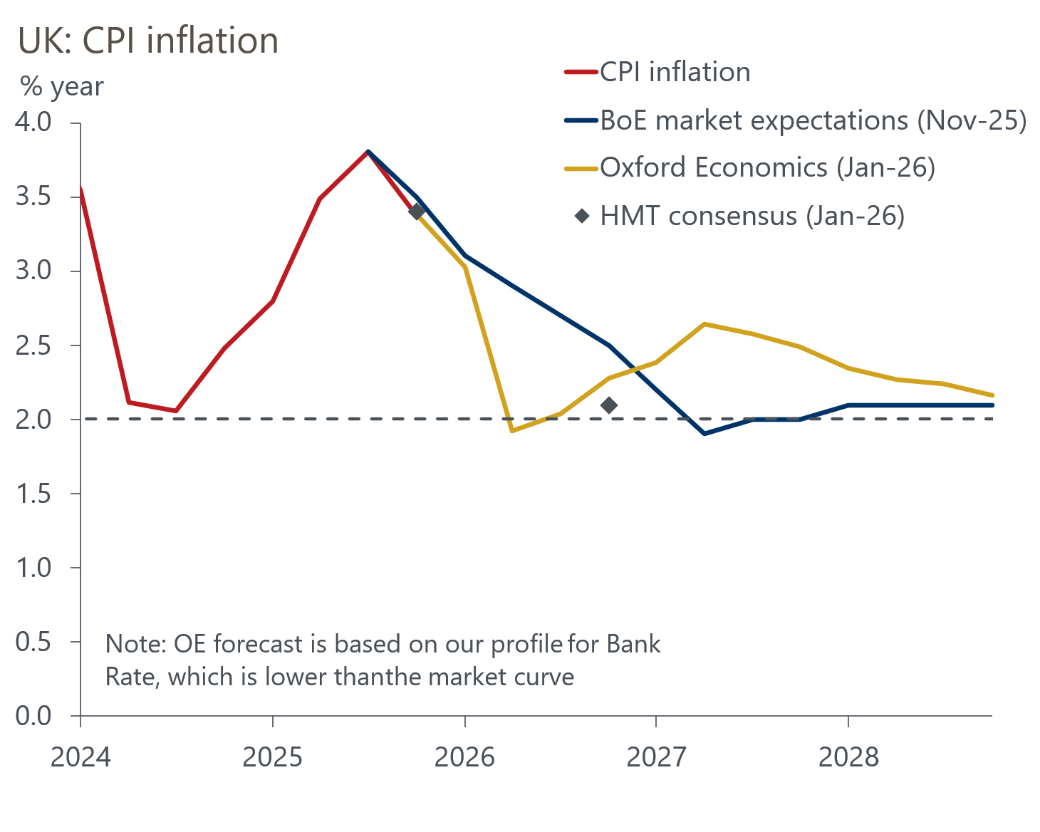
Sources: Oxford Economics, Bank of England, HMT
Recent favourable outturns mean February's inflation forecast will start from a slightly lower level than previously assumed. Meanwhile, the MPC remarked in December that one-off reductions to regulatory costs levied on households' energy bills, and changes to fuel duty, were likely to directly lower inflation by around 0.5ppts in April 2026.
Recent shifts in market expectations for Bank Rate, as well as relatively modest changes in sterling and commodity futures prices across the 15 working-day period used by the BoE to generate the forecast's conditioning assumptions, are unlikely to have a significant impact on the BoE's near-term inflation outlook.
Further ahead, we expect the MPC to raise its inflation forecast slightly above the 2% target in 2027. This reflects our view that several of the factors set to weigh on inflation in H1 2026 should prove temporary and unwind over the course of H2 2026 and 2027. This would send a message that the MPC intends to maintain its cautious approach to loosening policy further.
Separately, the MPC will also conduct its annual stocktake on the supply side, so there will be a lot of moving parts in the forecast. Given official productivity growth has remained weak and there has been a sharp slowdown in net migration in recent years, we think the BoE may flag that the risks to its potential output forecast are skewed to the downside.

Mild stagflationary conditions are likely to keep the MPC divided
The MPC introduced two new alternative scenarios for the economic outlook in November's Monetary Policy Report, as a way of helping to communicate where members saw the risks around the central projection.
The first alternative scenario is a negative demand shock, showing downside risks to inflation from greater weakness in output, especially in consumer spending, leading to a further rise in unemployment and slack in the economy. The second is mainly an adverse supply shock, showing upside risks to inflation, with elevated inflation expectations keeping pay growth above a target-consistent pace, without generating stronger economic activity. Most MPC members believe that one or the other of these scenarios is more likely to occur.
There has been a concerted effort by the committee to refer to these scenarios in discussions about the policy outlook. Swati Dhingra and Alan Taylor have suggested that they consider the downside scenario to be their baseline. The other members have intimated that they still see the central projection as their baseline outlook, but have placed different weights on the alternative scenarios. Bailey, Sarah Breeden, and Dave Ramsden have suggested that they put more weight on an outcome closest to the downside scenario, whereas Huw Pill, Megan Greene, and Catherine Mann have cited concerns echoing the upside risk scenario. Clare Lombardelli has shared those worries, but has also made efforts to acknowledge the downside risks from the weakness of consumer spending (Chart 4).
Chart 4: The MPC remains divided on the risks to the inflation outlook
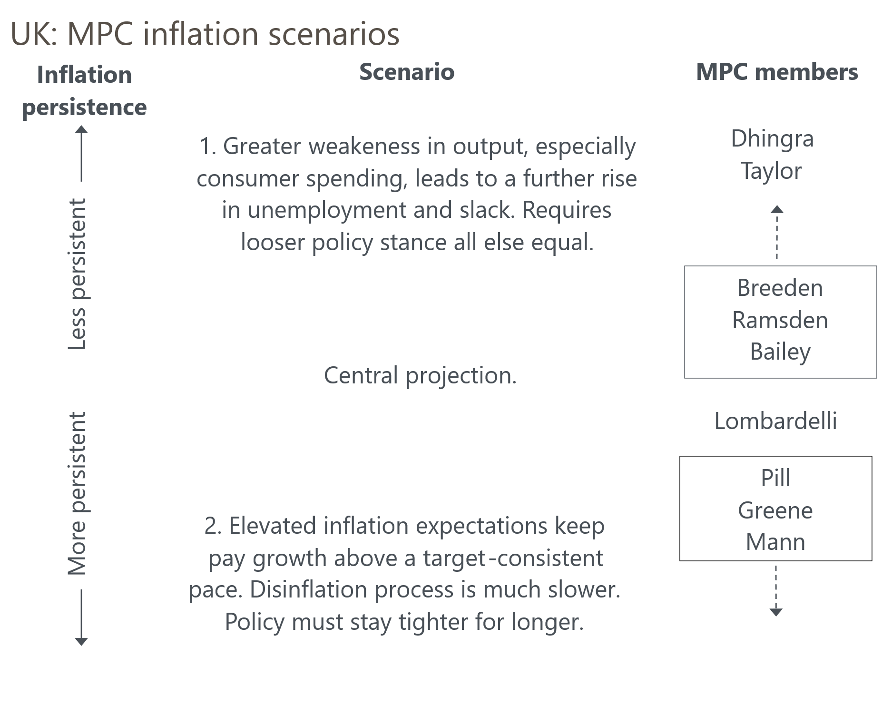
Source: Oxford Economics
We think the MPC will probably retain these scenarios for February's Monetary Policy Report. However, as we outlined in a recent Research Briefing, these alternative scenarios are not mutually exclusive. The mildly stagflationary environment that the UK finds itself in, with weak growth and upside risks to price pressures in the medium term, means we suspect elements of both scenarios are likely to materialise. This suggests that the committee is likely to remain divided for a prolonged period, encouraging a gradual approach to further policy loosening.

The MPC may use its report to signal that policy is approaching neutral
In December's guidance, the MPC emphasised that for individual members, judgements around further rate cuts would become a closer call as policy approaches neutral, and that there is a range of views on what level that is. As was the case in the February Monetary Policy Reports in 2024 and 2025, we suspect the BoE may include a box in next week's MPR laying out the latest research on where estimates suggest the long-run equilibrium interest rate sits, and what this implies for the current restrictiveness of monetary policy.
We expect the MPC's messaging around the neutral rate to remain guarded. However, considerable uncertainty about estimates of neutral and a sense that cutting too aggressively would be more costly than too little suggests the committee will continue to take a cautious approach to loosening policy.

We think April is likely to be the next meeting with genuine jeopardy
As of January 29, market pricing implies a 2% chance of a 25bp cut at the February meeting, and just a 14% chance of a cut by the March meeting. We agree that cuts at either of these meetings are unlikely.
The MPC's messaging in December signalled that its vote to lower Bank Rate was unlikely to be the start of a rapid series of cuts. We don't think the recent data have been weak enough to convince a majority on the committee to vote for a February cut next week. Indeed, there's a good chance that the vote split will be wider than December's 5-4 decision, with just Dhingra and Taylor likely to vote for a cut.
We continue to think that most committee members will be content with waiting until the end-April meeting to cut again. By that time, the MPC will be able to assess how the new year pay deals are materialising in the official data, and there should also be further evidence of subdued growth and slack accumulating in the labour market. After that, we expect the MPC's desire to move cautiously will see it only cut once more this year, in November.

